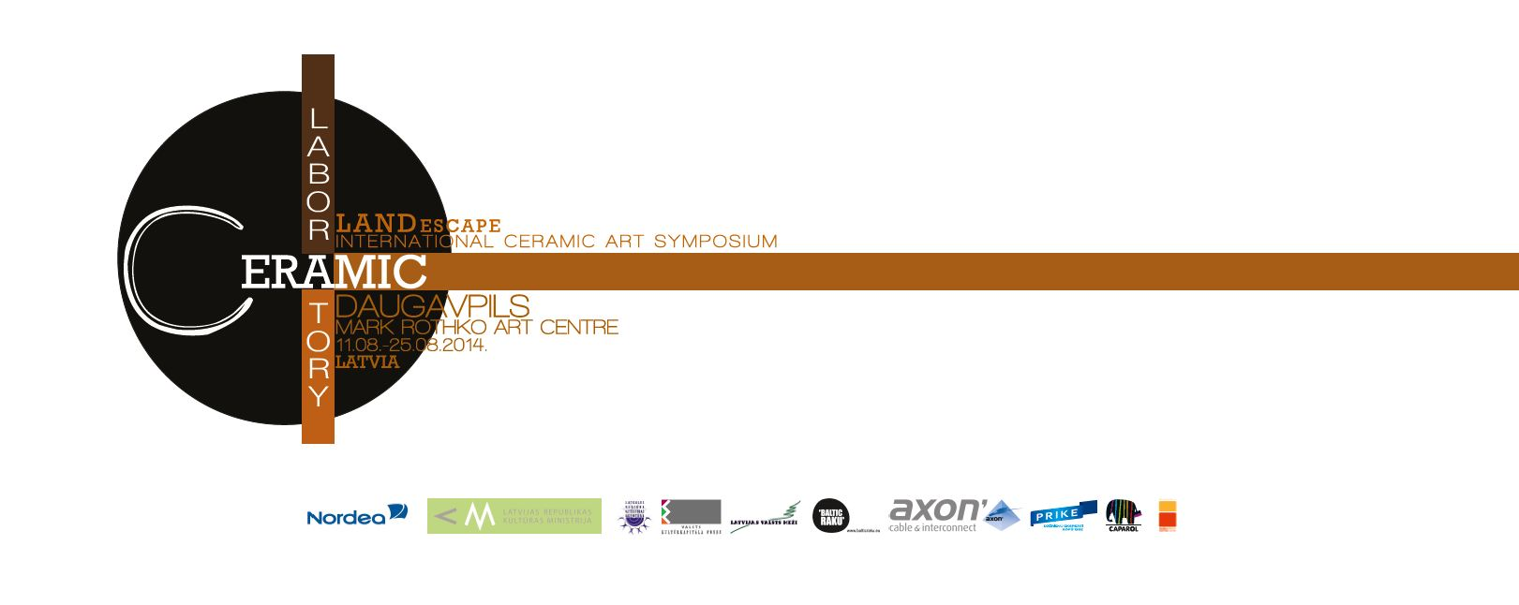
PROGRAMME OF PUBLIC EVENTS
Tuesday, August 12
4.00 PM | The opening exhibition of Symposium | Daugavpils Mark Rothko Art Centre,  Mihaila Street 3
Wednesday, August 13

8.00 PM | Presentations of the participants’ creative works.  Meeting with artists. | Daugavpils Mark Rothko Art Centre,  Mihaila Street 3
Thursday, August 14

8.00 PM | Presentations of the participants’ creative works.  Meeting with artists. | Daugavpils Mark Rothko Art Centre,  Mihaila Street 3
Festival of Experimental Firing Technologies

August 20-23

Wednesday, August 20
4.00 PM | LECTURE „Fermented ‘Baltic raku’. Similarity and Distinction with Other Raku Techniques” by Ilona Šauša (Latvia) | Ceramic laboratory  Hospitāļu Street 8
5.30 PM | OPEN DOOR WORKSHOPS  Janina Mironova’s (Poland) workshop on ceramic decals  (pre-register via tel. +371 26956160) | Ceramic laboratory  Hospitāļa Street 8
Thursday, August 21
9.00AM – 3.00PM | The day of Raku  The firing of ceramics using different raku techniques | Daugavpils Clay Art Centre,  18.novembra Street 8
Friday, August 22
all day | The firing of ceramics | Ceramic laboratory  Hospitāļa Street 8
4.00PM | Lecture „„Visualization of Undone: Computer Aided Artistic and Industrial Ceramic Visualisation" by Ufuk Tolga Sava (Turkey)” | Daugavpils Mark Rothko Art Centre,  Mihaila Street 3
5.30 PM | OPEN DOOR WORKSHOPS  Tatjana Jerošenko’s (Russia) workshop on creation of ceramic jazz music instrument kazu  (pre-register via tel. +371 26956160) | Ceramics laboratory  Hospitāļa Street 8
Saturtday, August 23
11.00 AM – 1.00PM | The pottery kiln opening | Ceramics laboratory  Hospitāļa Street 8
4.00PM | The opening of closing exhibition of symposium and recognition of participants | Nikolay’s gate (next to Rothko Centre)

